**Project Name:** Waste, Recycle & Feedback management system

**UI diagram**

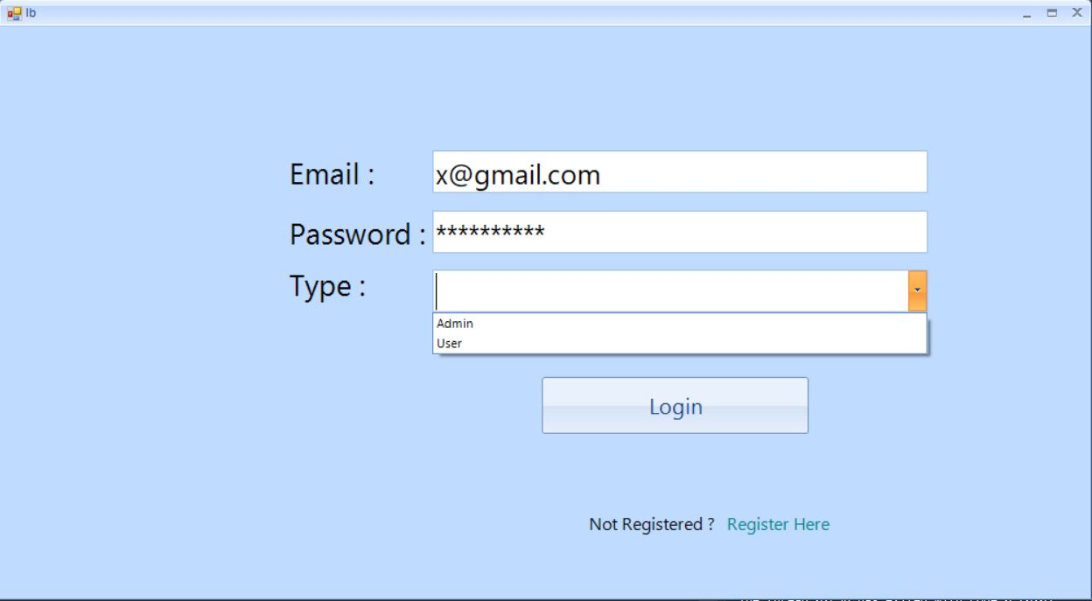

This is log in page. The admin or User can log in by clicking **login** button through this page & go to their profile page. If selected type is user, user profile page will open, on the other hand,if type is Admin, Admin profile page will open.

If the user is not registered in this system, he have to registration in this system. For this purpose, he have to click **Register Here.**

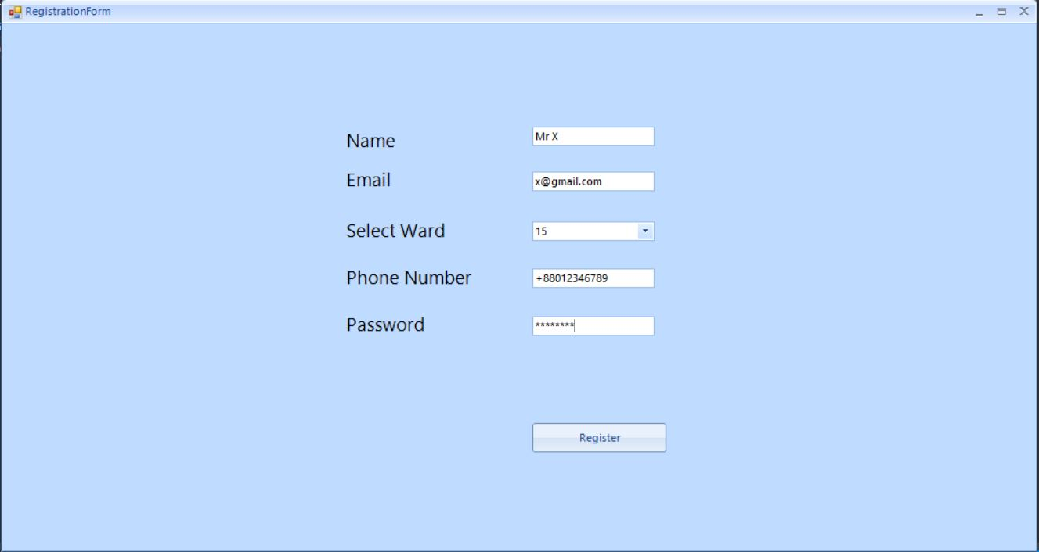

The user have to fill up this from and click the button **Register** for registration .Then he will go to the log in page for log in this system.

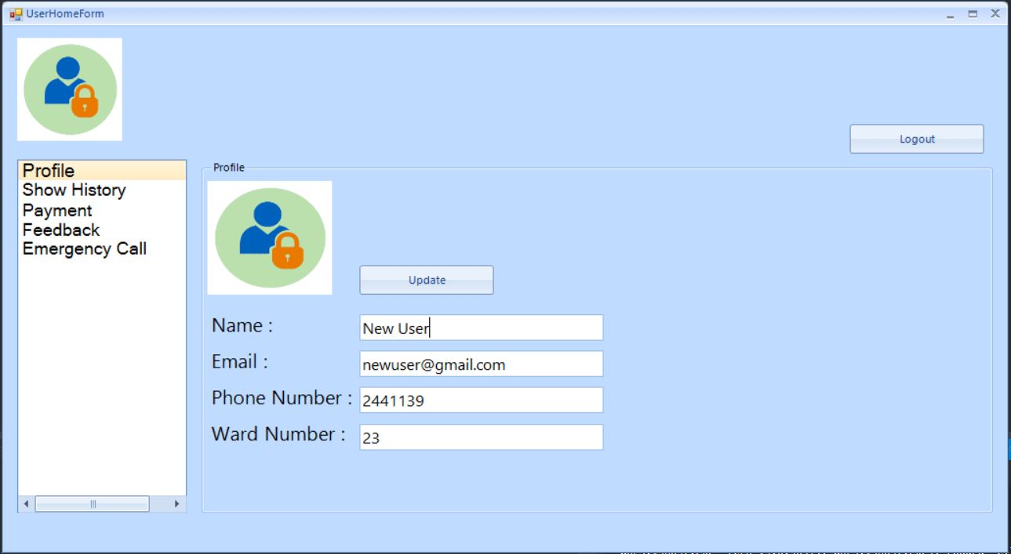

If the user select the type user in log in,he can see this page. if he click profile he can see hi profile. BY clicking **Update** button ,the user can update his profile.

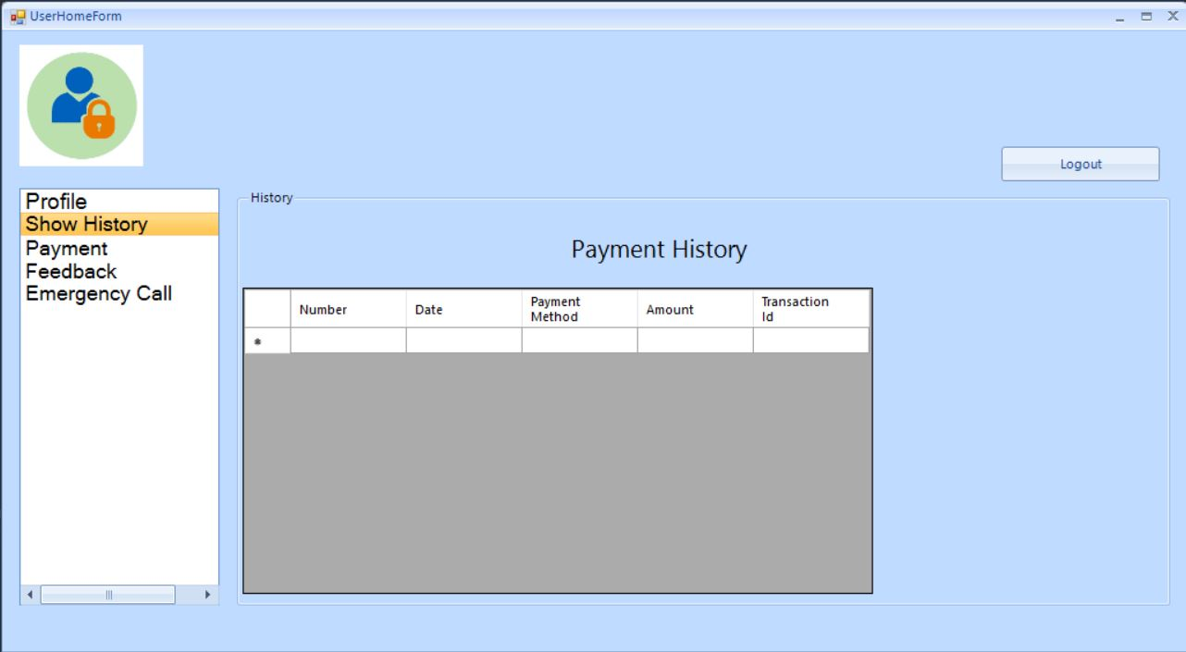

The user can see his payment history by clicking **Show History** button. He can see previous payment time,payment method, Amount & transection id in this page.

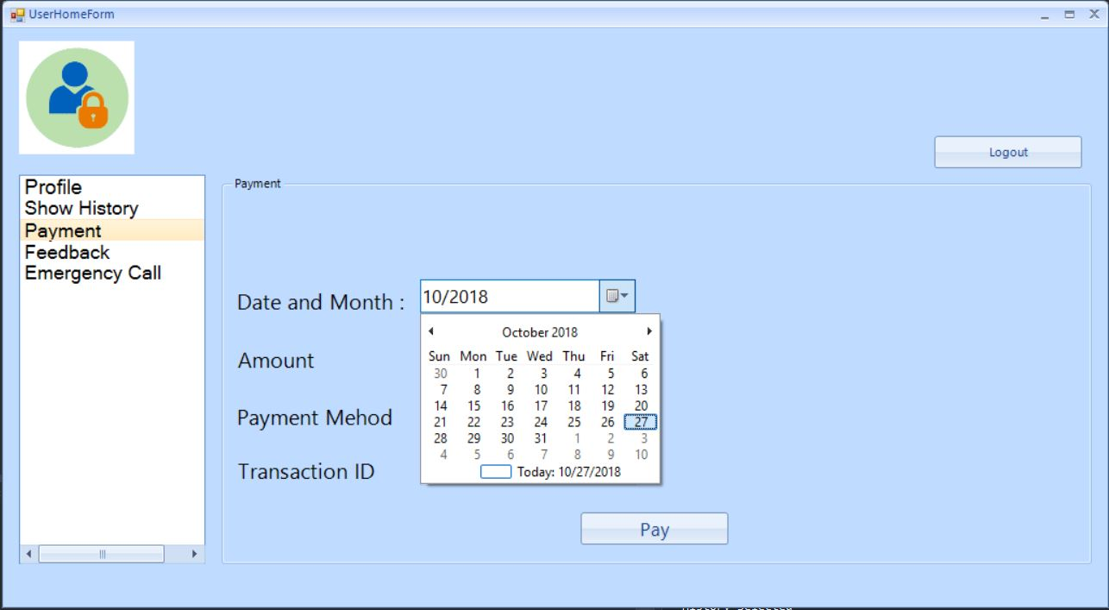

By clicking **Payment** button the user can pay bill from this option. He have to select Date & month, Amount, Payment Method, Transection id & by clicking the **Pay** button he pay is bill.

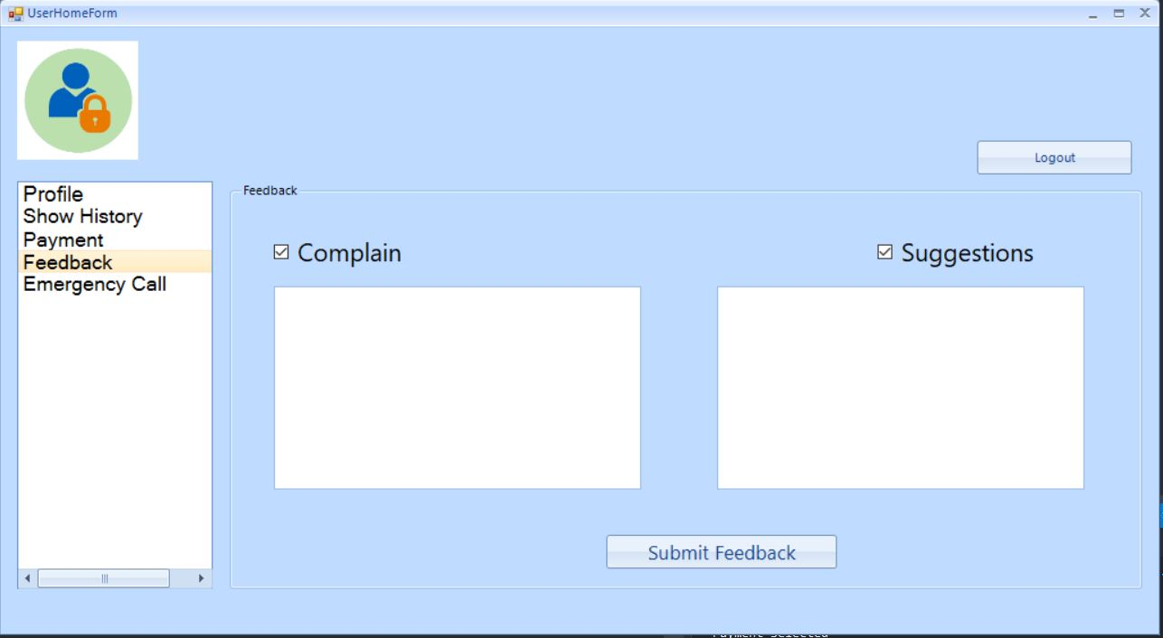

By clicking the **Feedback** button, the user can select either **Complain** or **Suggestion** or **both** and write complain & suggestion & click the **Submit Feedback** button.

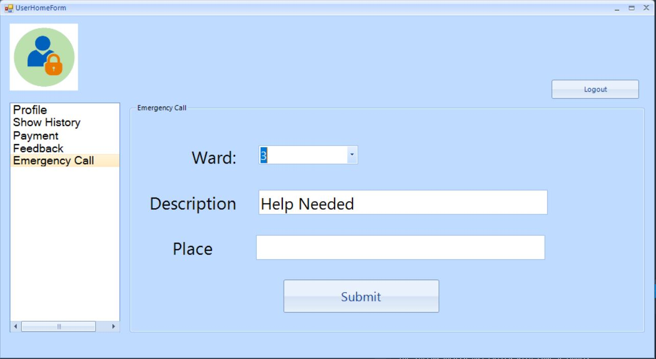

By clicking **Emergency Call** button, the user have to select his ward, write the details description, Place & click **Submit** button to submit the details.

There is also a **Logout** button in every page. The user can logout user profile page by clicking **Logout** button.

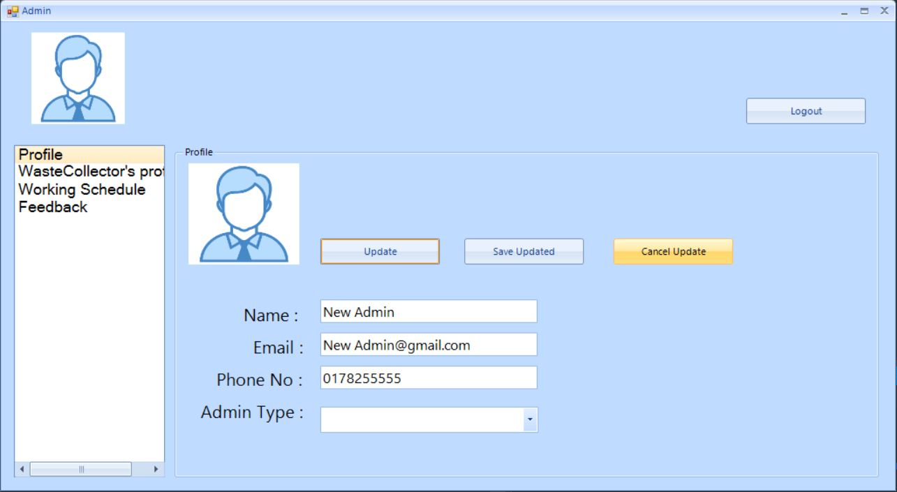

In login page, if the type is selected as admin. The admin can see this page.by clicking **Profile** button, admin can see his profile. BY clicking **Update** button, the user can update his profile. Admin can also save or cancel update by clicking **Save Updated** & **Cancel Updated** button

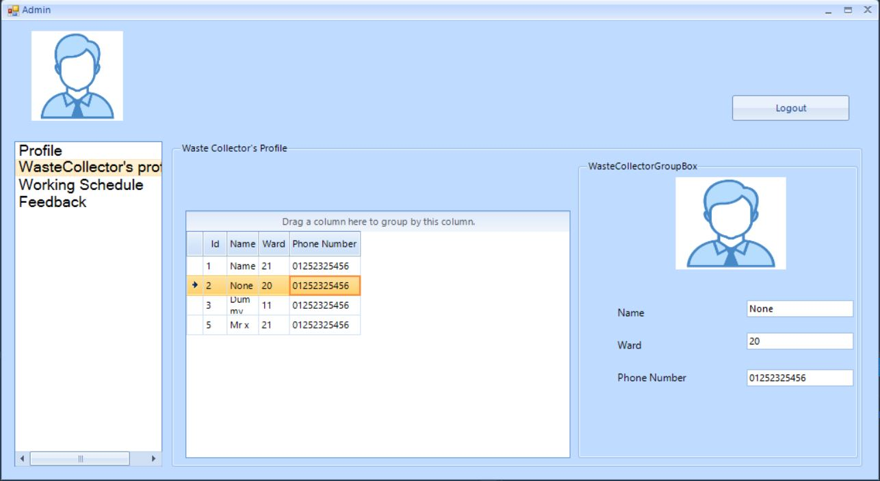

The admin can see details information about waste collectors by clicking **WasteCollector’s Profile.** If the admin want to see particular waste collector’s details, he have to click the row of the details table & can see the details beside the table.

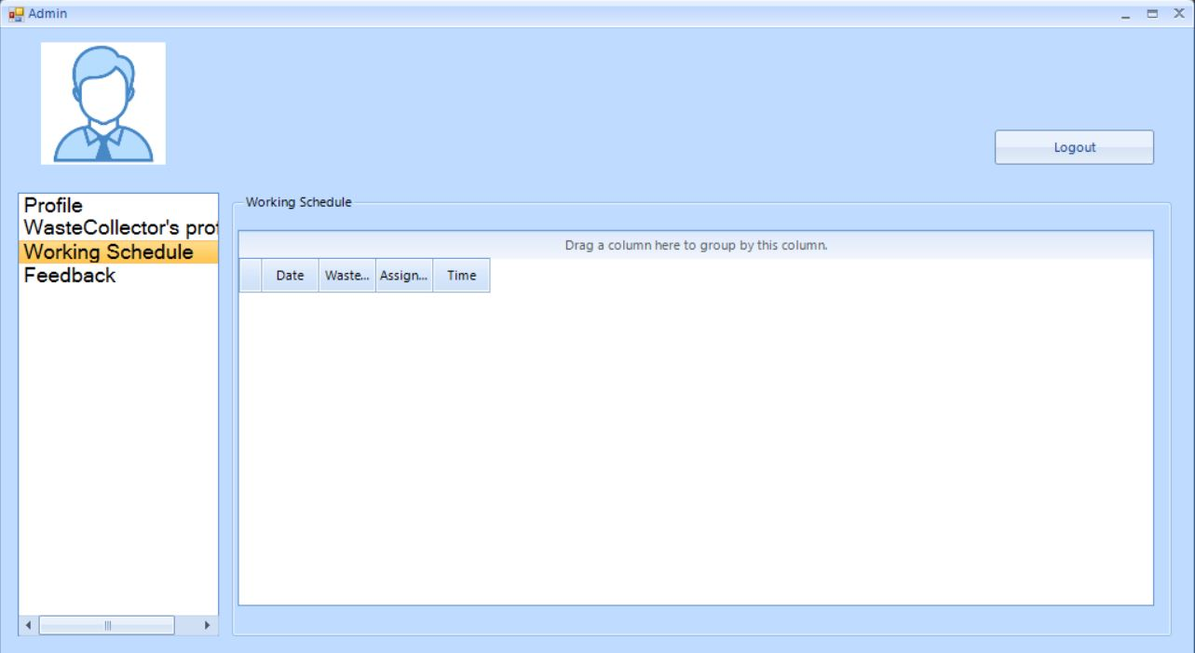

By clicking **Working Schedule,** the admin can see the working schedule in the page.

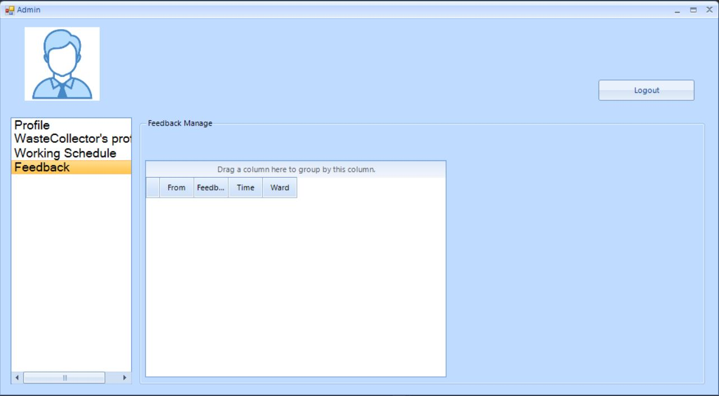

By clicking the **Feedback,** the admin can see user’s feedback.

There is also a **Logout** button in every page. The Admin can logout user profile page by clicking **Logout** button.